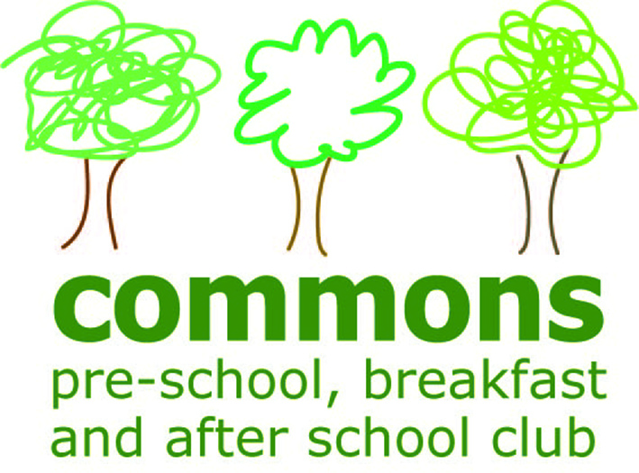
THE COMMONS PRE-SCHOOL, BREAKFAST AND AFTER SCHOOL CLUB
EY425329

Special Educational Needs and Disability (SEND) - Children and Families Act 2014
The Children and Families Act 2014 requires local authorities to publish, in a single place, information on services and provision across education, transport, health and social care for children and young people aged 0-25 with special educational needs and disabilities (SEND). The purpose of this ‘Local Offer’ is to enable parents, carers and young people to see more clearly what services are available for children with SEND in their area and how to access them. The process extends to early years settings and all the information below forms our setting’s offer and shows how we have, for many years, provided for children with special educational needs and disabilities.
Our Policy
We support children with special educational needs and disabilities by providing a positive environment in which all children are supported to reach their full potential.
- We comply with the Statutory Framework for the Early Years Foundation Stage and the Equality Act 2010.
- We have regard to the Special Educational Needs and Disability Code of Practice (2014).
- We ensure our provision is inclusive to all children with special educational needs and disabilities.
- We fully support parents of children with special educational needs and disabilities.
- We identify the specific needs of children with special educational needs and disabilities and meet those needs through a range of SEN strategies.
- We work in partnership with parents and other agencies in meeting individual children’s needs.
- We monitor and review our policy, practice and provision and, if necessary, make adjustments.
- We have a designated Special Educational Needs Coordinator (SENCO) who is our Manager Karina Saunders (PS), Lauren Evans (BC) and Michelle Weller and Claire Mason (ASC).
- Identifying Children with Special Educational Needs and Disabilities
- On induction to our Pre-School the SENCO and parents share information about the strengths and needs of the child to create a positive partnership. This may include a home visit and Stay and Play sessions.
- Families will be supported for as long as it takes for their child to settle. We want all children to feel happy and safe with us.
- Each child has a Key Person who works closely with each child and the family, and may identify a possible individual need.
- On-going observational assessments are made of all children and are linked to the Early Years Outcomes and Development Matters ages and stages of development (as outlined in the Statutory Framework for the Early Years Foundation Stage).
- We undertake a ‘Progress Check at age 2’ which supplies parents/carers with a short written summary of their child’s development.
- Reports from health care professionals may identify a child’s individual needs and we will include these in the child’s learning and development.

Supporting Children with SEND
- Our SENCO will work with all our staff to ensure our SEND provision is relevant and appropriate.
- We use the ‘graduated approach system’ for identifying, assessing and responding to children with special educational needs. This means using a step-by-step response through the various levels of intervention which are discussion of a concern, targeted support, specialist support and Education, Health and Care Plan (EHC).
- Our SENCO will explain how children’s individual needs can be met by planning support using a written Individual Learning and Provision Plan (ILPP) in conjunction with an Individual Education Plan (IEP), My Support Plan, EHC, or Health Care Plan.
- The Key Person will oversee the ILPP and IEP targets.
- ILPP and IEP targets will be reviewed and new ones planned by the child’s Key Person, SENCO, parents and professionals involved with the child.
- We access additional support from other professionals where necessary.
- Our SENCO will work with all other staff to ensure implementation of the ILPP and IEP and subsequent continuity of care and education by everyone.
- We ensure that parents are informed at all stages of assessment, planning, provision, monitoring and review of your child’s progress.
- Learning Journeys are available to view at any time and may be borrowed to take home.
- All documentation is kept in the child’s file in a locked filing cabinet to ensure confidentiality.
- Further funding can be applied for to support your child.
- Our SENCO has completed specific SENCO training and also attends regular Network Meetings and Clusters to keep up-to-date.
- Staff have attended training linked to specific needs and will attend further courses if required.
Accessibility of the Environment
- Ramp access into the building.
- Level entry.
- Disabled toilet available.
- Resources are easily accessible by the children who have free choice.
- We will explain the limitations of the building and would make changes or adapt our facilities if possible.
Working with Other Professionals
We have regular contact with the following professionals:
- Inclusion Development Officer
- Early Years Advisory Teacher
- Early Years Action Group
- Health Visitors
- Speech and Language Therapists
- Educational Psychologists
- Communication Disorder Team
- Local Children’s Centres
Advice from professionals in other areas may be sought as a need arises, such as:
- Child Development Centre (QEII)
- Physiotherapist
- Occupational Therapist
There are many other professionals who we can contact regarding a child’s specific individual needs.
Further Information
- The Key Person is always available for advice and support in the first instance. There is a list of every child and who their Key Person is within the setting.
- Our Manager and SENCO are also available to offer advice.
- We can signpost parents to other professionals that may be able to help such as health visitor, speech and language therapist, children’s centre and others (see lists above).
- If a child’s needs have been referred to a specific team, we will be able to support parents in accessing these services.
- Families Information Service
- Hertfordshire County Council Local Offer
Moving on to School/or Another Setting
- We hold transition review meetings to plan transition for a child into Nursery/Reception Class. As well as parents and Pre-School staff, these could include foundation stage school teachers, school SENCO, receiving setting staff and relevant professionals.
- We share all documentation such as ILPPs, IEP’s, My Support Plans, Early Years Assessments, Observations and learning Journeys.
- We invite receiving school/setting to visit our Pre-School to familiarise themselves with, and observe, the child and to share information in partnership with parents.
We operate an open door policy and our staff welcome families to visit our pre-school. We will aim to work together to include any child with special educational needs and disabilities.
Reviewed 22/7/2015

